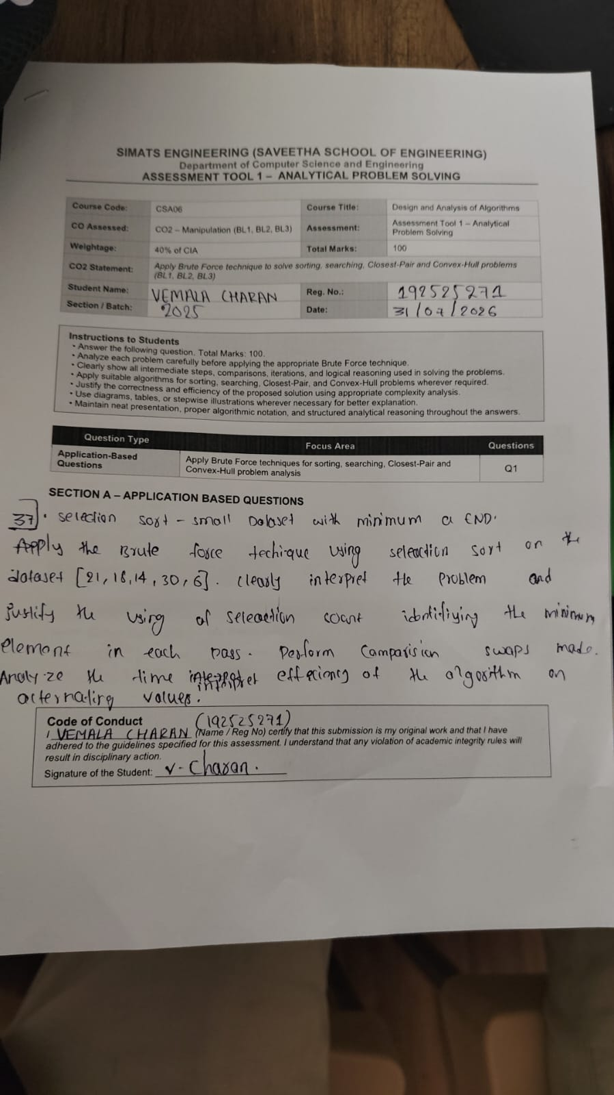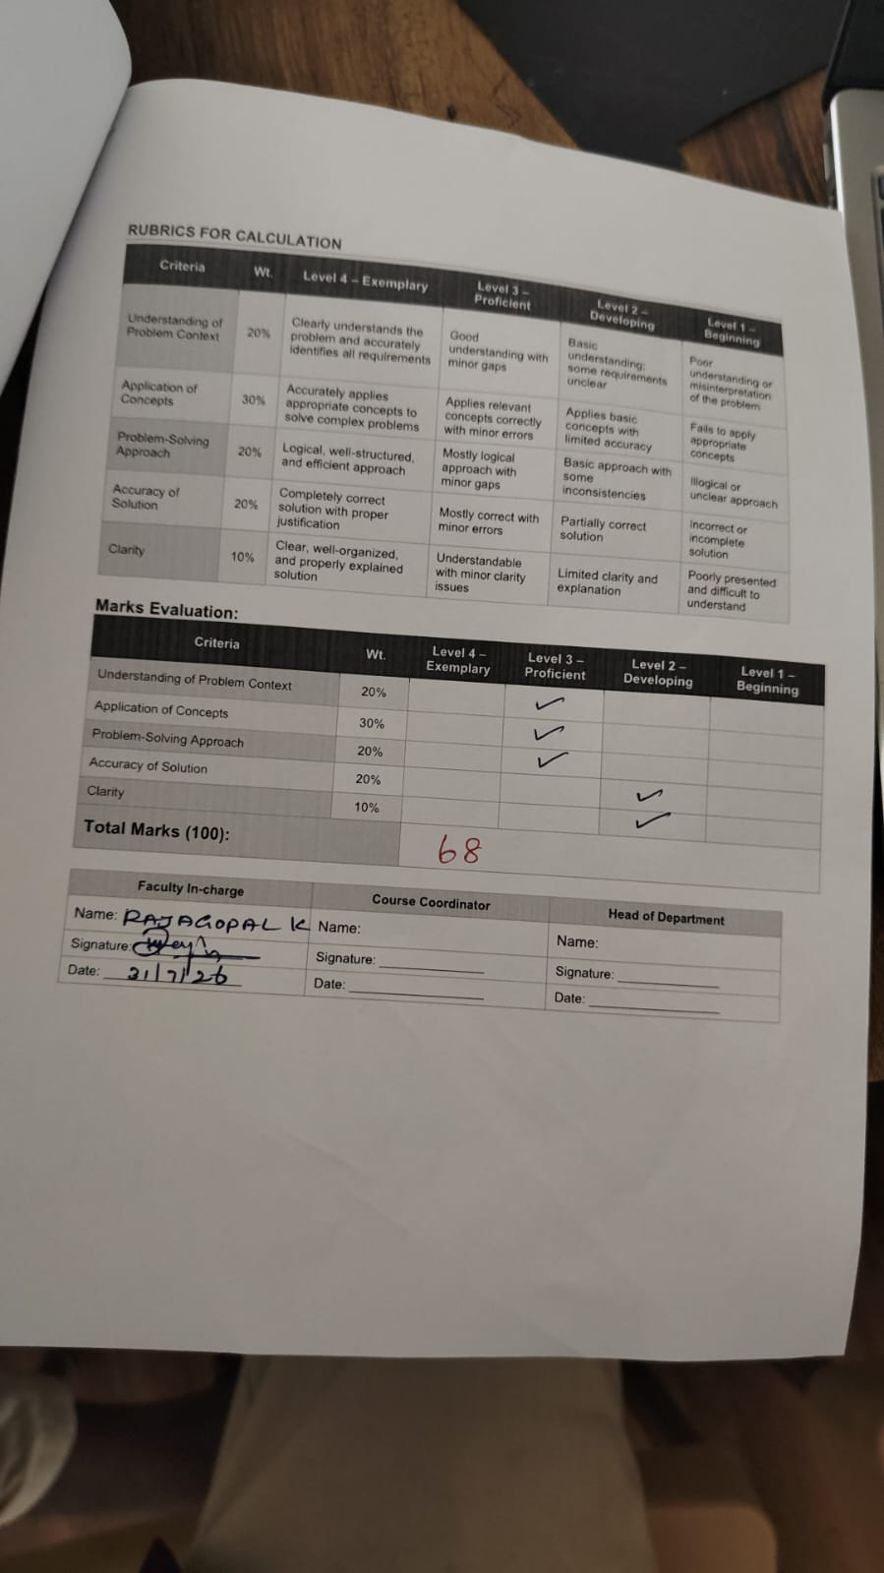SIMATS ENGINEERING ASSESSMENT TOOL 1
COURSE NAME: DESIGN AND ANALYSIS OF ALGORITHMS COURSE CODE: CSA06

COURSE OUTCOME COVERED
CO2: Apply Brute Force technique to solve sorting, searching, Closest-Pair and Convex-Hull problems (BL1, BL2,BL3)

Assessment Tool Weightage: 40%

QUESTIONS: 10 Total Marks:100

Annexure A

ANALYTICAL PROBLEM SOLVING

Code of Conduct:
I (Name / Reg No) certify that this submission is my original work and that I have adhered to the guidelines specified for this assessment.
I understand that any violation of academic integrity rules will result in disciplinary action.

Signature of the student:

Annexure A ANALYTICAL PROBLEM SOLVING

Q37. Selection Sort – Small Dataset with Minimum at End
Apply the Brute Force technique using Selection Sort on the dataset [21, 18, 14, 30, 6]. Clearly interpret the problem and justify the use of Selection Sort for identifying the minimum element in each pass. Perform the sorting step-by-step and show the array after each pass. Count the total number of comparisons and swaps made. Analyze the time complexity in all cases. Verify the correctness of the final sorted output and interpret the efficiency of the algorithm.

Algorithm → Growth Function → Big-Ω → Lower Bound → Best-Case → Performance Guarantee → Overall Performance
1. Algorithm
An algorithm is a finite sequence of well-defined steps used to solve a particular problem. The efficiency of an algorithm is mainly measured by its time complexity and space complexity.
2. Growth Function
A growth function represents how the running time of an algorithm increases with input size . Common growth functions are:
3. Big-Omega and Lower Bound
Big-Omega gives the asymptotic lower bound of an algorithm.
If
it means that for sufficiently large , the running time grows at least as fast as .
For example:
has
because the running time increases at least linearly with .
4. Lower Bound as Minimum Execution Time
The lower bound represents the minimum amount of computational work required under the specified analysis. It tells us that an algorithm cannot perform asymptotically better than the given bound.
For example, searching an unsorted array may require examining elements, giving a linear lower-bound behavior in the relevant setting.
5. Best-Case Analysis
Best-case analysis determines the minimum running time of an algorithm for inputs of size .
For example, in linear search, if the required element is the first element:
So the best-case time complexity is .
6. Performance Guarantee
The concept map can be extended as:
Lower Bound → Best-Case Analysis → Performance Guarantee
A performance guarantee specifies how efficiently an algorithm can perform under particular conditions. It helps determine whether an algorithm can satisfy required time and resource limits.
7. Importance of Best-Case Analysis
Best-case analysis is useful because it:
- Shows the fastest possible execution of an algorithm.
- Helps compare algorithms.
- Identifies favorable input conditions.
- Helps in understanding algorithm behavior.
- Can be useful in applications requiring very fast responses.
8. Overall Performance Understanding
Best-case analysis alone does not describe the complete performance of an algorithm. Therefore, best-case, average-case, worst-case, Big-O, and Big-Ω analysis should be considered together.
Conclusion
In DAA, the concept Algorithm → Growth Function → Big-Ω → Lower Bound → Best-Case → Performance Guarantee explains how algorithmic performance can be analyzed. Big-Ω provides a lower-bound perspective, while best-case analysis shows the minimum execution time under favorable inputs. Together with other complexity analyses, they provide a complete understanding of an algorithm's performance.

RUBRICS FOR CALCULATION

Analytical Problem Solving
Criteria | Weight age | Level 4 (Exemplary) | Level 3 (Proficient) | Level 2 (Developing) | Level 1 (Beginning)
Problem Understan ding | 20% | Clearly interprets problem, identifies all parameters and requirements accurately | Understands problem with minor gaps | Partial understanding  ; misses key elements | Misinterpret s or unable to understand problem
Method Selection | 20% | Selects most appropriate method/form ula with strong justification | Selects correct method with minor errors | Inappropriate or partially correct method | Unable to select method

Solution Process | 25% | Logical, systematic steps with correct approach throughout | Mostly correct steps with minor mistakes | Disorganized steps; multiple errors | No clear process
Accuracy of Calculatio n | 20% | All calculations accurate; correct final answer | Minor calculation errors | Frequent errors; incorrect final answer | No valid calculation s
Interpretati on of Results | 15% | Clearly interprets results with units and engineering relevance | Basic interpretatio n with minor omissions | Limited or unclear interpretation | No interpretatio n

